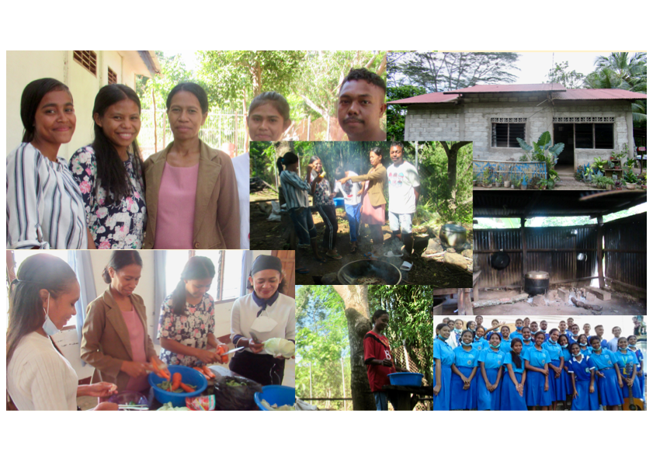

Prof Francisca Bui (Ika) goes way beyond the call of duty in her role of teaching English and Malay (Indonesian) at NOSSEF.

This is the story of Ika, a teacher
at NOSSEF secondary school.

I
t’s often difficult for us here at St Canice’s in Australia to understand the complexities of life, let alone the transforming role of education for the young in a fledgling nation like East Timor.

NOSSEF, the secondary school in our sister parish of Railaco treasures its rural roots as much as it strives for academic achievement. It is a ‘poor’ school with scholarships and dormitories for students from remote mountain communities eager to receive a good education. Achievement requires much more than financial assistance. The contribution of excellent teachers, motivated by faith and generosity, is what makes such a difference.

Ika is one such teacher. She was the youngest of six daughters in West Timor farming family. Her parents were keen to get her engaged after primary school. At the age of ten, Ika went to live with her sister and attended high school. A few years later, her parents started to support her education and Ika studied English for four years at a Catholic University in Kupang (Indonesia). This is where she became acquainted with her future husband, a man from Railaco.

Family and cultural traditions can be very demanding. Ika had to experience a lot of suffering with her father-in-law. When she gave birth to her first daughter in 2015, he counted the cost of raising his son and often asked his son and Ika to pay him.

She embraced reality and learned how to tackle problems. From time to time, she thought of returning home. “God has given me more than I asked him,” she told herself. When she said this, she couldn't hold back her tears. But she said that she has always been comforted and encouraged by her husband.

S
ince 2016 Ika has accepted five students into her home. Most of them are not her own family.

They are NOSSEF students from distant districts. She generously provides her home for poor students who need housing to attend school. They help with household chores and take care of small kiosks run by Ika’s family.

She says, “I sometimes feel that I don't have a family here, but God has given me more than I asked him. I’m happy to accept those students at our home as they help us in cooking and farming.” She takes a breath and says in confidence, “I don't feel lonely anymore.”



